

*Table of Contents*

Project Description 3

Research 4

API 4

Features and Coding 4

Requirement Sepcifications 5

Client Feedback Review 6

High Level Site Flow 6

Development Stages 10

Project before the Feedback Presentation 10

Project in the weeks that followed after the Feedback Presentation 10

Summary & Conclusion 12

***Project Description***

Pixel Library is a data search resource for media such as Games, TV-Shows and Movies. The mash up allows us to take data provided from our APIs into a massive database of information of any of the chosen media or all three at once.

The API we are using have changed since we first detailed out our project. This is due to our research finding a problem with some sites API and forcing us to rethink how we can use it. The current API we use are

* Twitch API
* OMDB
* YouTube API
* GiantBomb
* TMDB

The API allows us to create a detailed page to give each user an insight into the media they are searching. Each of the search results having an accompanying link to YouTube trailers and for games we have embedded Twitch steams for people to see the game being played. The page also includes reviews and descriptions based from OMDB pages for each movie, TV show or game in the database. And that’s Pixel Library.



***Research***

API

The original API we used were going to be Netflix, Twitch.tv and YouTube. Once we began to research into programming and using the API we ran into problems almost straight away, when we discovered Netflix had stopped supplying API keys to new developers. This meant that we had to try and find a new API to replace it. We took a look at other APIs but none worked well for us until we found an API called OMDB. This API allowed us access to a massive media database of games, movies and TV-shows which ended up giving us more data than Netflix would have given us in the first place. Along with this we used an API called TMDB to help with the search database. This allowed us to get movies, TV shows and games with only partial titles instead of having to enter exact names into the search.

A lot of this process was hindered with team members getting lost on code and having to lead API coding from any information we could find on it from the internet. This made the task quite a long and drawn out process.

Features and Coding

Some major changes came from the research that happened before the first line of code was even written up. We decided that NetBeans was not up to the standard that we were looking for and we decided to go to notepad++ as it gave us more flexibility with how we code the project and what we can add into the project to give it more volume. The downfall to this decision was that we would not have the aid of the NetBeans design page, but we felt our skills in programming would allow us to overcome this.

The search engine also was a major hit backward for us. We quickly had to abandon the randomised search we were hoping to do at the beginning and instead focused on fleshing out the search engine we had for going through the database and letting users have a wipe variety of media to go through and discover. The coding of the search and making it just as we wanted it took a lot of time and was a high priority for us throughout the project.

In the end each problem we had was overcome due to the hard work of each team member and the amount of research and development of ideas we put into it. The research speaks for itself in the final mash-up; its ability to run as well as it does is testament to the teams work.

***Requirement Specifications***

The original requirement specification we produced outlined our idea for where we wanted the project to go and what we wanted to see it turn into. Over the week that followed the beginning of programming the project we found we had to strip down much of what we had wanted to see and wanted to include into the mash-up. The original specifications were:

* Randomised suggestion on Media through small questionnaire
* A database taking data from the APIs to assemble a list of media for the search to use
* A non-randomised search allowing for full browsing of the entire database
* A series of links allowing users to move to the site of each API for the purpose of information about the media
* A full description and overview of the media
* A review database to be able to score each media

Throughout the time we spent after the specifications doing research into the API development much of it had to be stripped out and replaced or changed in some way. The removal of the randomised suggestions due to difficulties programming out a generator for it is one example of this. But some things were added as we found the ability to do some coding proved much more simple than expected. After all research our final Specification became:

* Search feature allows for the user to do a comprehensive search for individual media or all three at once.
* Each Media is given a full plot description as well as a review on the mash-up page.
* Pulls Top 5 Twitch.tv streams for searched games onto the Mash-up page.
* Each Media has a YouTube trailer given to it that will be shown through the Mash-up page.
* Comment system allows for users to leave reviews
* Log-in and Registering system in full use. Allows for users to use the comment and review system.
* “Everything Searches” can be reordered through what media it will prioritise.
* Front page ever updated list of top 5 TV and Box office showings.

***Client Feedback Review***

During our feedback session our project was met with some criticism, mainly focused on the technical side of things. We paid most attention to the points raised in relation to the project not being a complete mash-up yet and that the search was not as comprehensive as it could be. There were points raised with the name we have given our project as well as the styling of the project. These were put as secondary to the technical aspects but were dealt with over the weeks that followed.

We feel as though we took on each criticism in our stride and fixed many of the problems raised with the project. We let the feedback give us better direction in the time we had left and let us give the project the proper attention it needed to really show off what we wanted to see.

With regards to the client feedback, and what they wished to see advanced upon, the project was upgraded to a full mashup, implementing Twitch, YouTube, and OMDB together as one collective database. The search feature became much more comprehensive, allowing users to make a search across all mediums (movies, TV shows and games), as well as separate searches. On top of that, you can now sort out the order in which search results appear. Users can now type in a title, and they will be greeted with any movies containing that word in the title.

The mashup’s look was updated as well, going from the relatively plain original, to a more vibrant, eye-catching design, with a nice, clean logo to compliment it. The name of the project was also questioned, but we have elected as a group to keep it the same, as Pixel Library.

***High Level Site Flow***

The main homepage, where you can search your preferred media

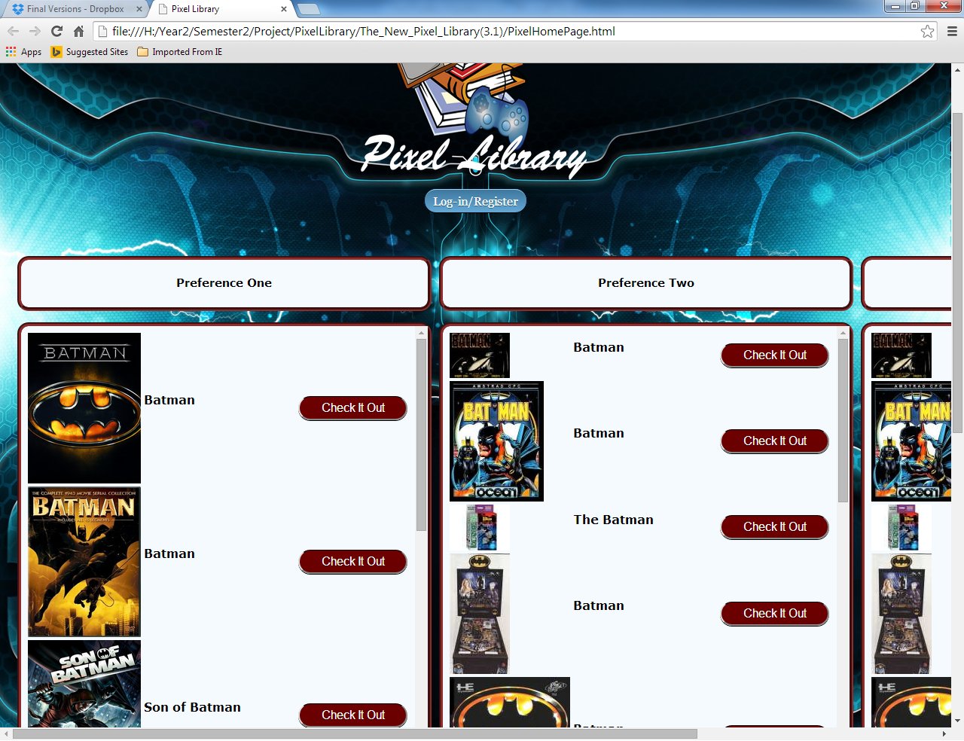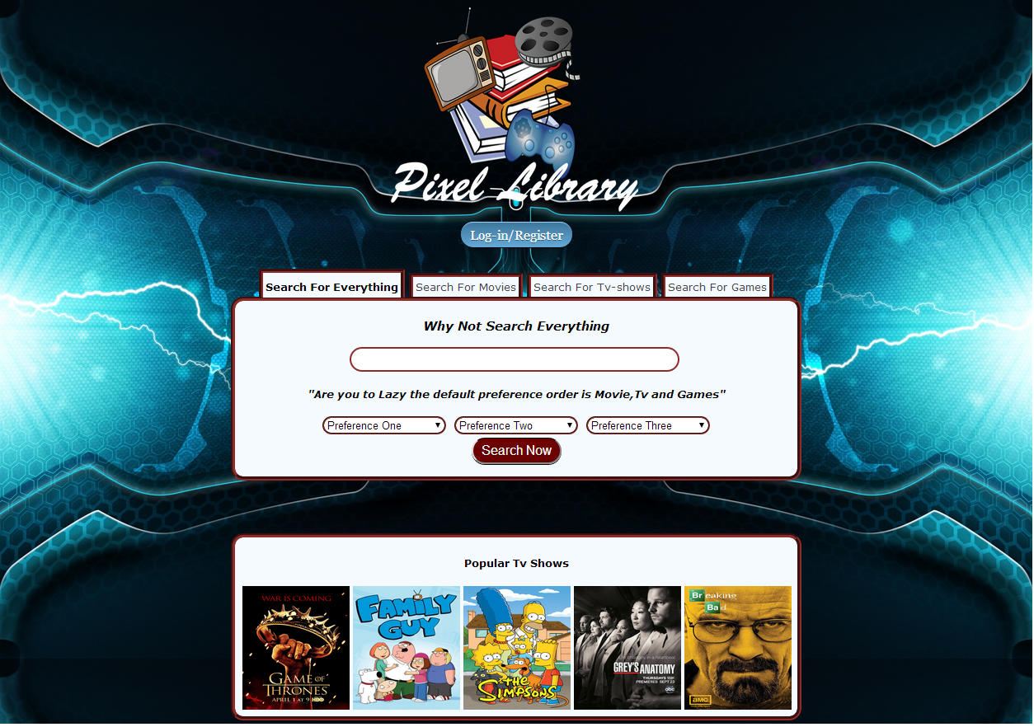The search results page, showing the range of titles available

The movie results page, showing what is available

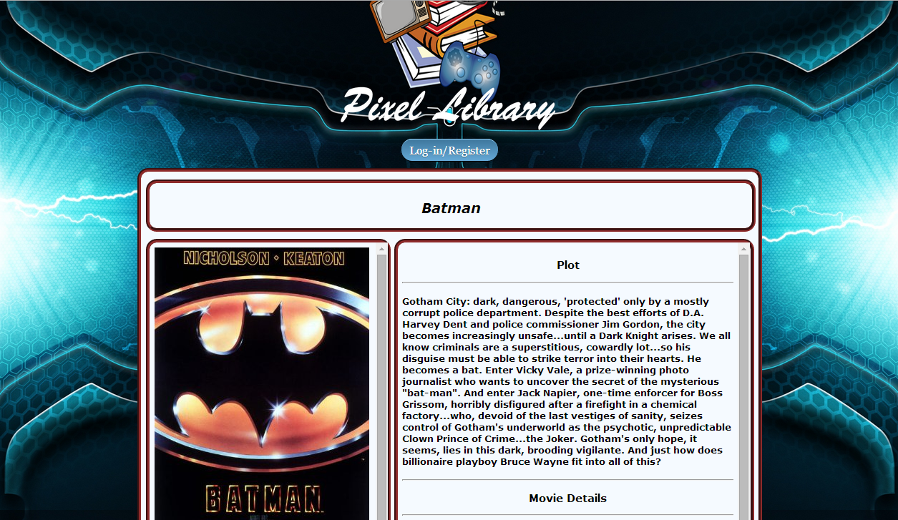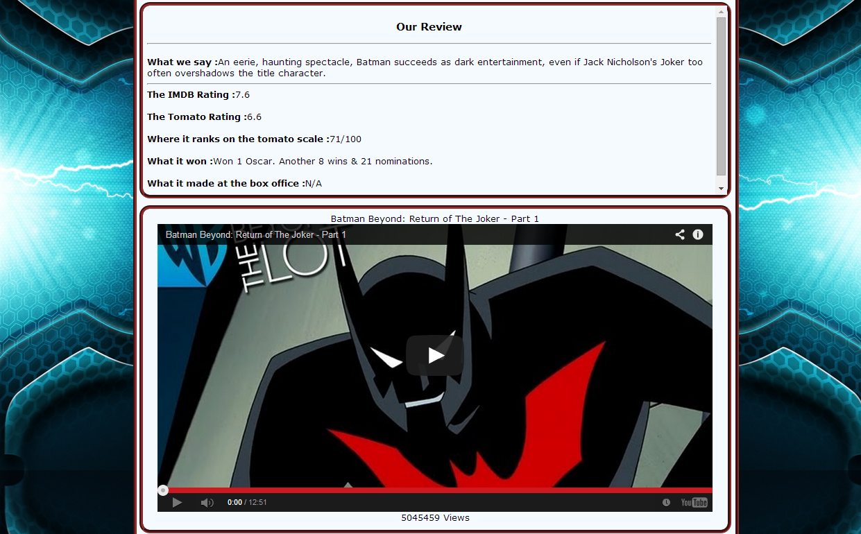

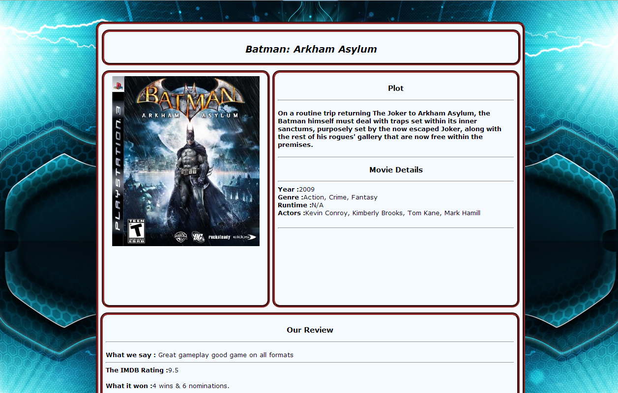The games results page, with a trailer, and a Twitch.tv stream

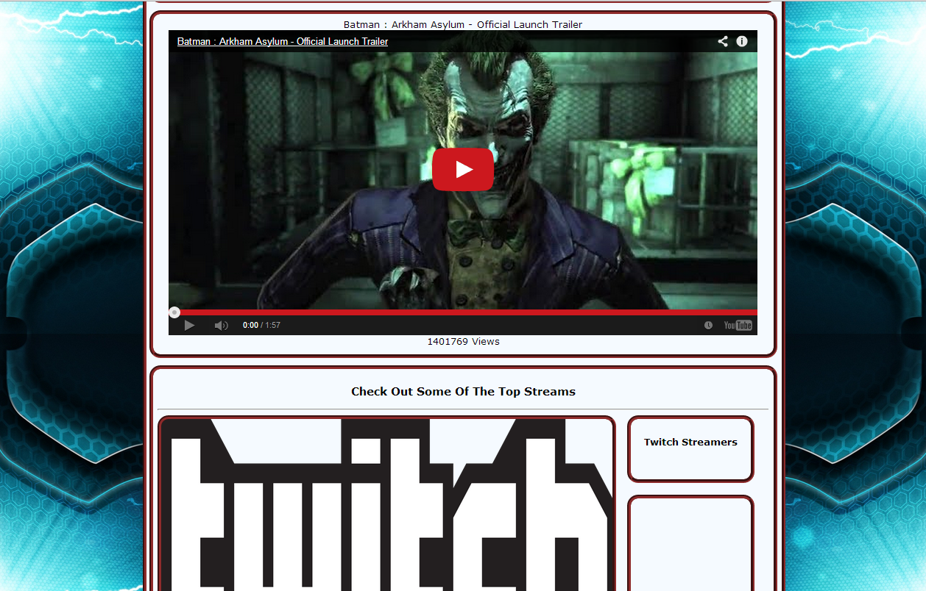

***Development Stages***

Project before the Feedback Presentation

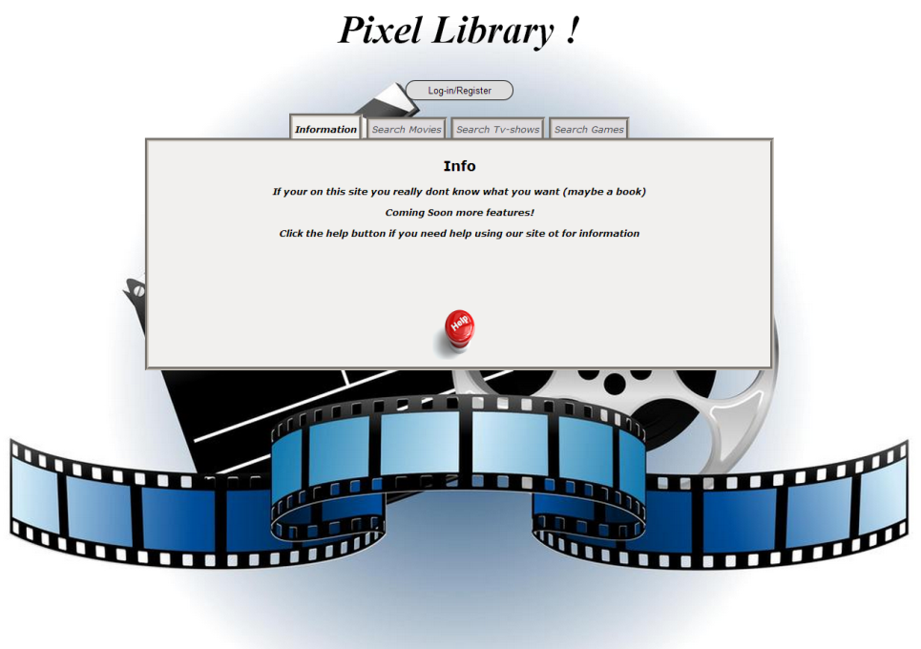

Project in the weeks that followed after the Feedback Presentation

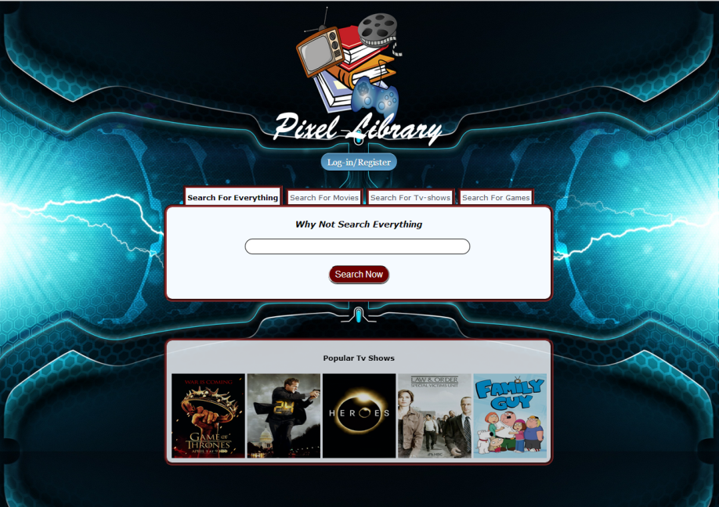

Tasks List

Below is a list of the team members and their contribution to each section of code they did.

Jamie Mulvaney:

* Overall compiling of website
* Styling
* Bug fix and editing
* OMDB and TMDB API

Giovanni Antipala:

* Comment system
* Log-in and Register Server
* Database

Eoin Magee:

* YouTube API
* Twitch.tv API
* Research and development on API implementation

Connor Ward:

* YouTube API
* Twitch.tv API

Joanna Bautista:

* YouTube API
* Twitch.tv API
* Research and development on API implementation

### Use Case Diagram

The below use case write ups are detailed reports of the functional requirements listed above.

### Accessing Database Requirement One

**Description & Priority**

This would require the access of Netflix, Twitch.tv, and YouTube’s library of content and results.

This has a high priority, as if the database cannot be accessed, the mashup would be useless

**Use Case**

Each requirement should be uniquely identified with a sequence number or a meaningful tag of some kind.

**Scope**

The scope of the use case is to describe the process of accessing the library of results and content

**Description**

The use case describes the steps taken in accessing content

**Flow Description**

**Precondition**

The system is in initialisation mode when the Actor (mashup user) is entering the mashup page

**Activation**

This use case starts when an Actor (mashup user) begin to search for a movie/game/TV show

**Main flow**

1. The system identifies the ………….
2. The mashup user searches a query(See A1)
3. The system returns content/results(See E1)
4. The user selects and streams content

**Alternate flow**

A1 : <title of A1>

1. The system returns results
2. The user exits out of the mashup
3. The use case continues at position 3 of the main flow

**Exceptional flow**

E1 : <title of E1>

1. The system finds that the search query does not exist in the library
2. The user is alerted to the error
3. The use case ends

**Termination**

The system presents the next set of results

**Post condition**

The system goes into a wait state

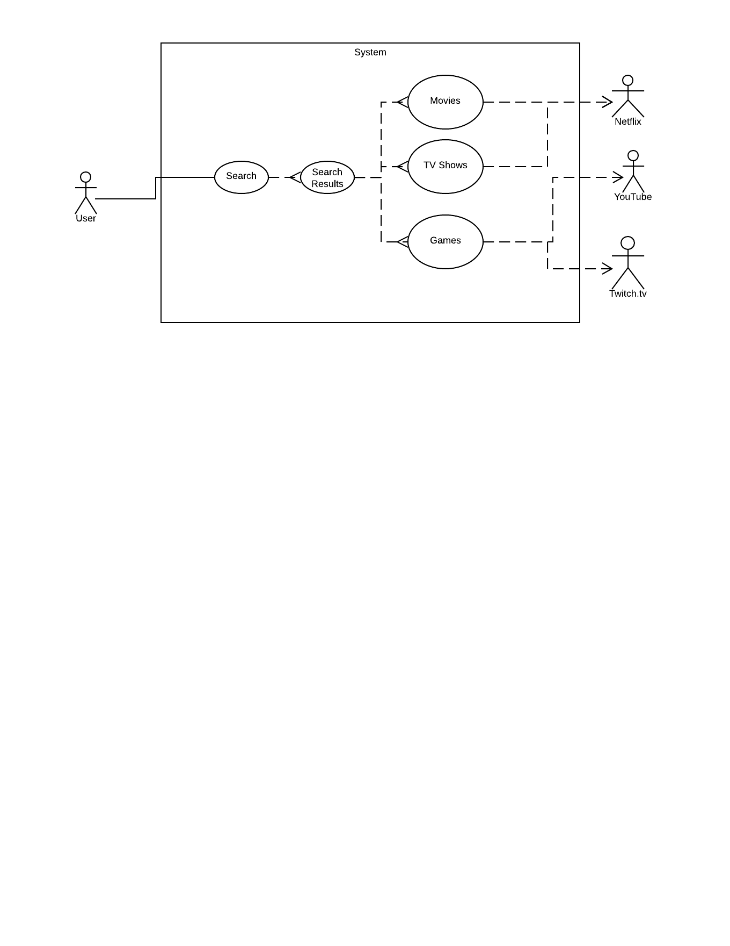

### Review System Requirement Two

**Description & Priority**

This requires the implementation of a review system, accessing Netflix/Twitch.tv/YouTube’s reviews, and streaming the results

**Use Case**

Each requirement should be uniquely identified with a sequence number or a meaningful tag of some kind.

**Scope**

Description of the process of streaming/adding reviews

**Description**

This use case describes the steps required to access the reviews

**Flow Description**

**Precondition**

The system is in initialisation mode when a user accesses the library

**Activation**

This use case starts when a user clicks the “Add Review”/|”View Reviews” button

**Main flow**

1. The system identifies the query
2. The user requests a review(See A1)
3. The system streams the reviews(See E1)
4. The user selects/adds a review

**Alternate flow**

A1 : <title of A1>

1. The system cannot find a review
2. The user is informed
3. The use case continues at position 3 of the main flow

**Exceptional flow**

E1 : <title of E1>

1. The system crashes
2. The user restarts
3. The use case continues at position 4 of the main flow

**Termination**

The system presents the next result

**Post condition**

The system goes into a wait state

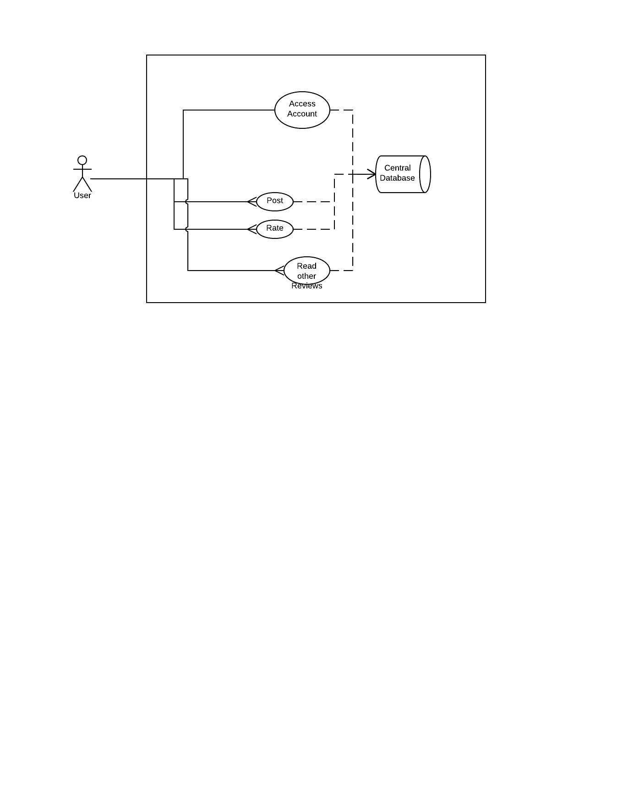

### Advanced Search Engine Requirement Three

**Description & Priority**

The requirements must be completed and filled in correctly or else the search engine would give inaccurate results.

**Use Case**

**Scope**

The scope of this use case is to show how advanced search engines process its queries.

**Description**

This use case describes the advanced search engine that provides fields for the user for more specific results.

**Flow Description**

Search engine waits for the user input then provides all the corresponding information needed.

**Precondition**

The system is in initialisation mode when the fields are filled in correctly.

**Activation**

This use case starts when the client uses advanced search.

**Main Flow**

1. Client chooses between simple search and advanced search.
2. If advanced is chosen, fields will be provided.
3. After completing fields in correctly, the engine will execute and provide the corresponding information.

**Alternative Flow: <IF FIELDS IS INCORRECTLY>**

1. Wait for user input.
2. Execute.
3. Provide inaccurate results/prompt
4. Ask client to complete the fields again.

**Exceptional Flow: <IF SEARCH IS INVALID>**

**<ALTERNATIVE FLOW 3>**

1. Prompt client: “Search is invalid”
2. Execute.

**Termination**

When the search is done, fields are reset for the next query.

**Post-condition**

Re-direct to the homepage that the client uses.

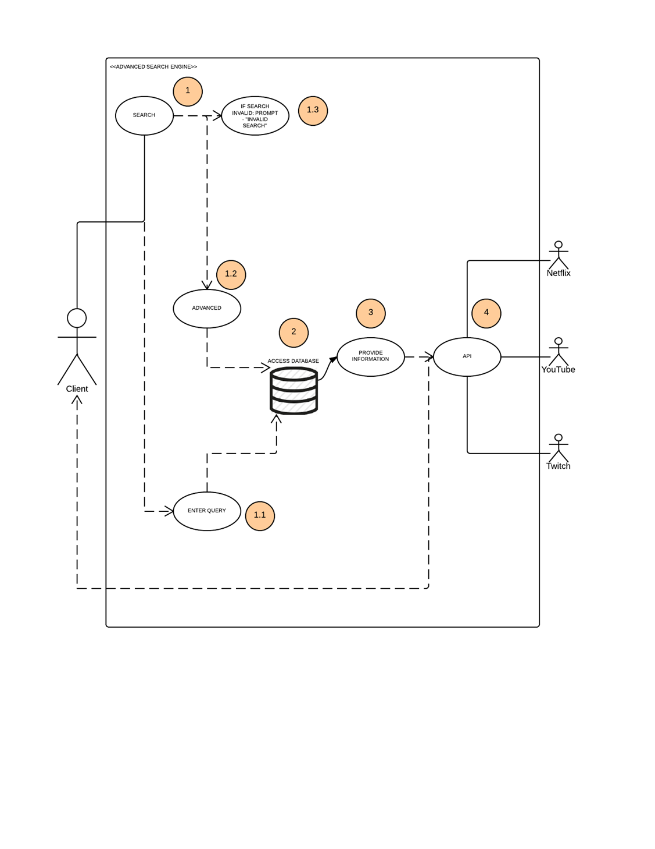

### Connecting to youtube Netflix twitch and IMDB Requirement Four

**Description & Priority**

Connectivity with Youtube, Twitch, Netflix and Imdb is an integral part of our website.

The main priority of it is to retrieve information from the four websites by accessing their API data via the search engine. The information then gets through our database and travels back out to the client. In this case, it would make it easier for the users to discover and explore more entertainment.

**Use Case**

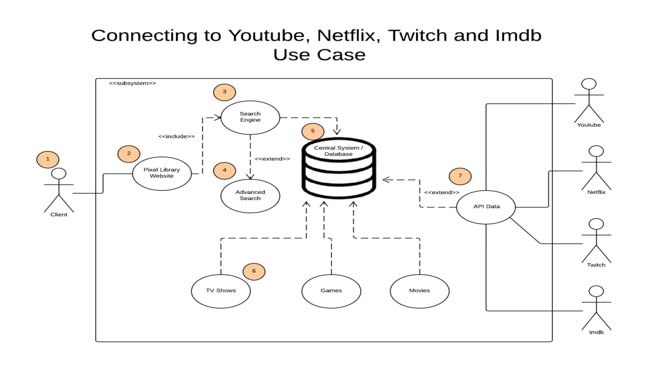

**Scope**

A client or user could either find what they are looking for by using the search engine and advanced search in our website. The requested information goes in our database, retrieves the requested information from the API data of Youtube, Netflix, Twitch and Imdb and goes back to the client.

The client will not be able to sign in his/her account through our website therefore we would need to redirect them to the main websites of Youtube, Netflix and Twitch; However they will be able to maintain their activities easily using our website. The client/user will not have to log in to the Imdb website as its purpose is to implement and add description to the movies and TV shows that will be shown as well as the images and titles, on our website.

**Description**

This use case describes the steps involved in retrieving information from the API data of the four websites that we are linked with. Our central system or database will store cached TV shows, Games, Movies and other informations from Youtube, Netflix, Twitch and Imdb. The other purpose of our database is to store reviews and user details.

**Flow Description**

**Precondition**

We need to ensure the capacity of our database to be able to store vast amount of data. We also need to make sure that the user has an account in Youtube, Netflix and/or Twitch for them to be able to do certain activities.

**Activation**

The user should type in the search engine to look for a specific movie, game or TV show.

**Main flow**

1. The Pixel Library website will have the search engine at the first page.
2. The user has to choose whether to go for advanced search or just the typical search engine.
3. The user has to type a specific movie, game or TV show on the empty field of the search engine.
4. The requested information goes through the central system or database.
5. The database retrieves the requested information from the API data of Youtube, Netflix, Twitch and Imdb.
6. The information gets stored on the database and then goes back to the client.
7. If the user wants to use his/her account from Twitch, Youtube and Netflix, we will redirect them to the main individual websites.
8. If a problem occurs, the user or client can send queries to the help button provided on the page.

**Alternate flow**

A7 : <Use Twitch, Youtube and Netflix accounts>

1. We will redirect the client or the user to the main websites of Youtube, Twitch and Netflix for them to log in on their account so they can maintain their activities while using our website.
2. After redirecting them, they can go back to our website and repeat the 3rd to 6th procedures.

**Exceptional flow**

E8 : <Help Page>

1. If an error or a problem occurs, the user can click the help button and send an email or post queries on the page.
2. An admin will help solve the problem.

**Termination**

If all the procedures are followed successfully, related results will show on the page.

**Post condition**

The user will have the choice to pick what TV show, movie or game they prefer on the results provided.

**Diagram Reference:**

UML Use Case Diagrams: Reference

**In-text:**(Msdn.microsoft.com, 2014)

**Bibliography:**Msdn.microsoft.com. 2014. *UML Use Case Diagrams: Reference*. [online] Available at: http://msdn.microsoft.com/en-us/library/dd409427.aspx [Accessed: 18 Feb 2014].

### Full Description from IMDB Requirement Five

1. Fields are completed correctly.
2. Accurate query.
3. Correct spelling.

**Description & Priority**

1. If the fields are not completely filled, search cannot execute.
2. Misspelled queries might give inaccurate results.
3. The priority is to get fields to be completed correctly, so it could give accurate results to the client.

**Use Case**

**Scope**

The scope of this use case is to provide full description of films from IMDB via search engine.

**Description**

This use case describes the functionality of the search engine. It provides advanced search and full description of a query. All fields must be filled in correctly and completed to receive accurate results.

**Flow Description**

1. Fields are completed via search engine.
2. Engine executes.
3. Results are provided.

**Precondition**

The system is in initialisation mode when the fields are completed correctly.

**Activation**

This use case starts when an advanced search engine is chosen.

**Main flow**

1. Client chooses between simple search and advanced search.
2. If advanced is chosen, it will provide fields that need to be completed correctly.
3. It will execute and provide results to the client.

**Alternate flow**

**<INCORRECT FIELDS>**

1. System Executes.
2. See main flow #2 – Prompt client “Invalid Search”.
3. Ask user to complete the fields again.

**Exceptional flow**

**<INVALID SEARCH>**

1. If invalid search redirect client to home page.

**Termination**

The system redirects user after successful query.

**Post condition**

The system goes into a wait state and empties the fields after the query.

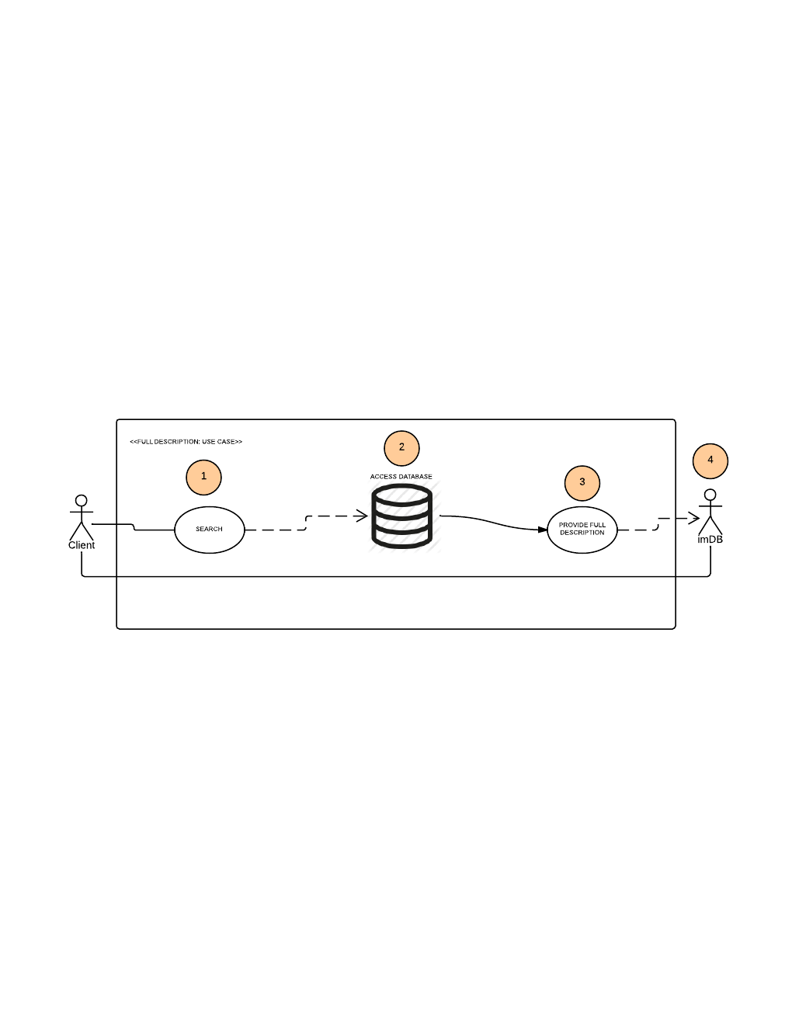

### Login and Register users Requirement Six

**Description & Priority**

The “Log In” requirement is an optional part of our website. Its priority is to provide users with ability to rate and write a review about a specific media which makes it easier for the users to access their account without going to the actual websites of Youtube, Twitch, Netflix and Imbd individually.

**Use Case**

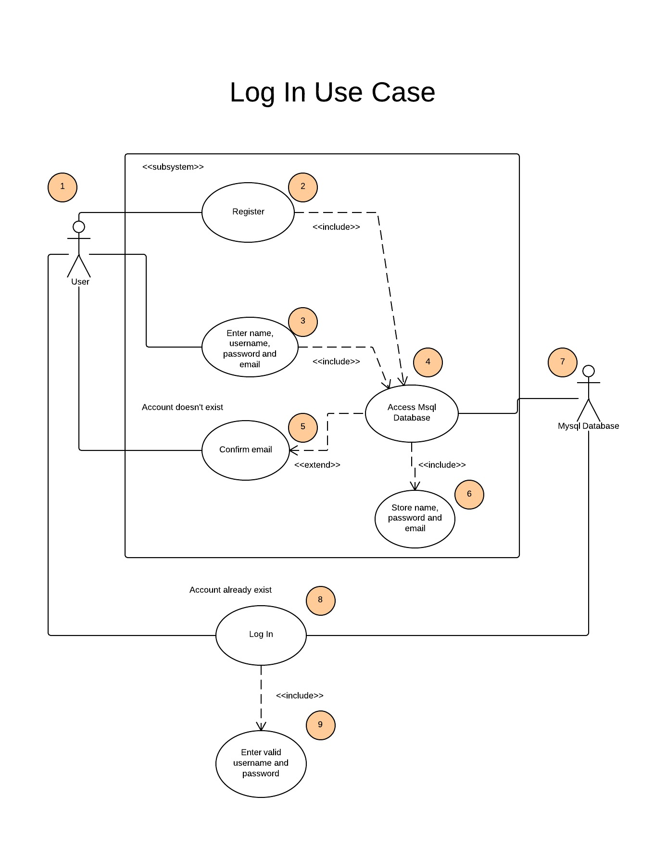

**Scope**

The scope of this use case is to log in and store user details in order to enable users to add reviews and ratings about a specific media they have previously watched or played.

**Description**

This use case describes the steps involved in logging in to our website. It has two actors that represent the end user and our database. There are nine steps in total depending on a situation to achieve logging in. The user will have a choice of registering or logging in directly. If the user doesn’t have an account, they will have to sign up. The register will require name, password and email. This information will be then stored in our database. They will be allowed to post reviews about the movies or TV shows they’ve watched and games they have played.

**Flow Description**

**Precondition**

When log in is pressed, a prompt will appear saying “Enter username and password”. A user should have username and password to log in. If a user doesn’t have an account yet, he/she should have at least a valid email for confirmation and for security reasons when registering.

**Activation**

The user is required to enter name, password and email address.

**Main flow**

1. The log in and register buttons on the website identifies the required fields to be filled so that the user will be able to rate and write reviews.
2. If the user has an account already, the user could skip to step 8 and 9 directly to log in and access the database.
3. The log in page will provide empty fields to be filled in.
4. The users will have to enter a valid username and password.
5. If the username and password gets accepted, the website will enable the user to access the database and thus will be able to rate and write reviews on the website that will be stored on the database.
6. If the user doesn’t have an account, he/she will have to register. This will be an alternative solution to log in.

**Alternate flow**

A6 : <Register>

1. If the user failed to log in directly, the alternative solution is to “Register” as what I have stated in the main flow and showed in the log in use case diagram.
2. The register page will provide all the required fields to be filled in.
3. The user will need to enter their name, email, chosen username and password.
4. The system will send an email validation to make sure that there will be no redundancy occurring.
5. If the email is verified then the user details will be stored in the MySQL database.
6. If the email or username has been successfully accepted, then these data will be stored in the database.
7. The user will have access to the database and will be able to post review on the website.
8. If the user finds any trouble registering, he/she can send an email to the administrators.

**Exceptional flow**

E8 : <Failure of Registering>

1. The user can click the help or troubleshooting button provided on the website and can send his/her queries.
2. The user will have to include his/her email when writing a query.

**Termination**

A prompt will appear saying “Log In successful” if the user has successfully logged on.

**Post condition**

The user will be able to add reviews and ratings on the website about the TV shows and movies they have watched and games they have played.

**Diagram Reference:**

UML Use Case Diagrams: Reference

**In-text:**(Msdn.microsoft.com, 2014)

**Bibliography:**Msdn.microsoft.com. 2014. *UML Use Case Diagrams: Reference*. [online] Available at: http://msdn.microsoft.com/en-us/library/dd409427.aspx [Accessed: 18 Feb 2014].

## Non-Functional Requirements

The Non-functional requirements below are selected from ones that apply to this mash up in particular. They outline the advantages of the requirements we have applied to the mash up.

### Availability requirement

The mash up will require a decent level of management to keep the system running all the time. Due to the relation needed with the internet for the programme to work and access the API’s there are limits to where the mash up can be used

### Robustness requirement

The API used in the mash up were chosen due to the large amount of data available from them that can be used for the mash up to make sure we have a database that is as complete and well-rounded as possible

### Maintainability requirement

The main flaw within the mash up is that its lifespan in its current state is directly linked with three other websites. This means that if one of these goes down it would mean a great amount of changes to the programme would need to be made for the mash up to be able to continue functioning.

### Extendibility requirement

The mash up can boast a large and extensive database that if done right can include data equal to one of the largest media database on the web. This means that with a lot of reduced work on our part we can have a large extensive Mash up

### Reusability requirement

Due to the random search engine the mash up has, the amount of times you can use and reuse it extends far beyond limits. This is because while there is a massive amount of media out there for people to access many take advantage of watching a movie many times which extends the reusability many time over

Future Improvements

If we were to continue this or repeat it with more time to spare we would put more focus into giving user a personalized profile. Letting them upload avatars and allow for people to see the reviews and comments they write. This would allow people to build up a reputation on the site which makes them more inclined to use the site and encourage new users onto the site. It also allows for users to see reviews from respected users that are proven to give good reviews giving the site a reputation for better reviews.

We would be able to also spend more time styling the site and fixing small problems with pictures in the search and maybe giving users more ability to search through tags instead of just title names. This adds to the feature giving users flexibility when it comes to finding new and different media on the site. These problems are ones we have tried to fix during the time we had but due to the way API bring data through to the site it made it hard to fix the problem completely.

***Summary & Conclusion***

The project flowed well over all and the brief we were given has been completed to the best of the abilities of the team members. Each API and feature has been implemented and works giving us not only the completion of the brief but also going beyond the brief in many respects. Each member of the team did the work they were given mostly and the project achieved a level of completion we didn’t expect to be able to reach at the beginning.

Although we ran into multiple problems and errors within the coding each was taken, broken down and remade with a solution efficiently as possible. Many times this meant we came out of a problem with a better product than was expecting of the original idea if it had worked well. This occurred with both the APIs we have used as well as the features we implemented within the mash- up, Each one complementing both other features and the API they run alongside.

Overall the group is happy and takes a sense of pride from what we have created and produced within the time frame we were given at the start of the semester considering we also had to juggle many other projects and modules while working on it.